|  |  |
| --- | --- |
| **Passive Optical Components** | **Pigtail** |
|  |  |

Welltech Enterprises pigtail is equipped with one connector on the end of fiber. Welltech Enterprises produces a full series of patch cord and pigtail which include FC, SC, LC, ST, E2000 type and etc.; SM and optical fiber or drop cable type. In addition, Welltech Enterprises also produces armored patch cord that can be directly laid in the center office and all kinds of extremely environment.

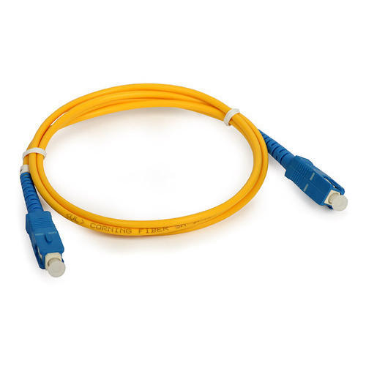

|  |  |  |
| --- | --- | --- |
| **FEATURES** |  | **APPLICATIONS** |
| ●Small bending radius and excellent flexibility |  | ●[CATV](https://en.wikipedia.org/wiki/CATV) |
| ●Stable performance, good compressive strength, tensile strength, anti-aging properties |  | ●Telecommunication Networks |
| ●Small diameter, light weight, strong practicability |  | ●Computer Fiber Networks |
| ●G657A class optical fiber or customized, cost-effective, stable parameter |  | ●Fiber Test Equipment |
|  |  |  |

|  |  |
| --- | --- |
| **Parameter** | **Conditions** |
|  |  |
| **Operating Temperature** | -40℃~+85℃ |
|  |  |
| **Storage Temperature** | -40℃~+85℃ |
|  |  |
| **Atmospheric Pressure** | 70~106KPa |
|  |  |
| **Wavelength** | 850nm、1310nm、1550nm |
| **Insertion Loss** | ≤0.3dB |
|  |  |
| **Return Loss** | PC≥45dB, UPC≥50dB, APC≥60dB |
|  |  |
| **Repeatability** | ≤0.2dB |
|  |  |
| **Interchange Ability** | ≤0.2dB |
|  |  |

**Active connector**

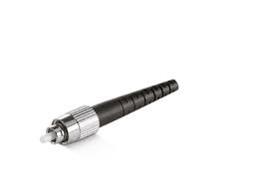 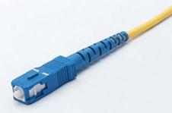 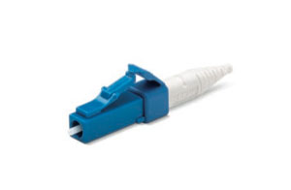 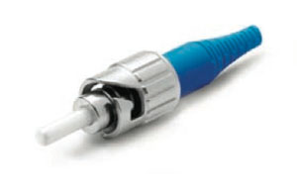

FC SC LC ST